Vernon Jackson Smith

Professor Hubbard

CS162: Intro to Computer Science II

04/26/2020

Polymorphism Challenge Part2-UML Diagram

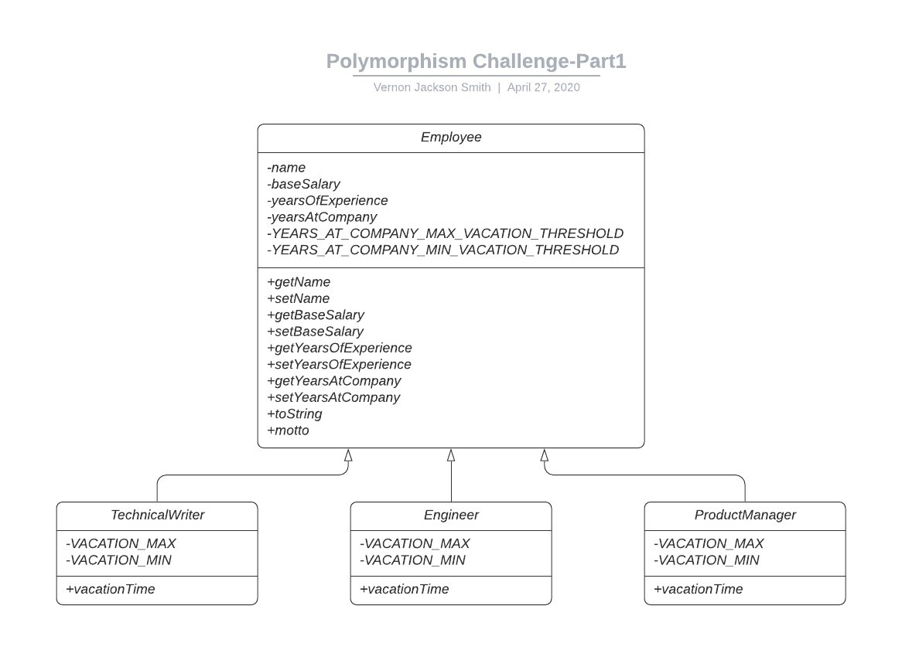

Owner

+giveRaise()